**1. create a customer table to store following columns, customer id as primary key**

**customer id, name, mobile set<int>,email tuple(text,text),purchaseveh map<text,int>,hoobies list<text>**

cqlsh:iacsd0923> create table customer (

cid int primary key,

cname text,

mobile set<int>,

email tuple<text,text>,

purchaseveh map<text, int>,

hobbies list<text>);

cqlsh:iacsd0923> select * from customer;

cid | cname | email | hobbies | mobile | purchaseveh

-----+-------+-------+---------+--------+-------------

(0 rows)

**2. insert 5 records with customer id 11,12,13,14,15**

cqlsh:iacsd0923> insert into customer (

... cid,cname, email, hobbies, mobile, purchaseveh)

... values(

... 11,'Ganesh',('ganesh@gmail.com'),['Swimming', 'Designing'],

... {9922},{'Milk':3,'Bread':4});

cqlsh:iacsd0923> insert into customer (

... cid,cname, email, hobbies, mobile, purchaseveh)

... values(

... 12,'Amrut',('amrut@gmail.com'),['Trekking', 'Traveling'],

... {9923},{'Cheese':1,'Butter':6});

cqlsh:iacsd0923> insert into customer (

... cid,cname, email, hobbies, mobile, purchaseveh)

... values(

... 14,'Vikram',('vikram@gmail.com'),['Reading', 'Traveling'],

... {9924},{'Paneer':8,'Butter':6});

cqlsh:iacsd0923> insert into customer (

... cid,cname, email, hobbies, mobile, purchaseveh)

... values(

... 13,'Kalpesh',('kalpesh@gmail.com'),['Dancing', 'Traveling'],

... {9925},{'Paneer':8,'Milk':3});

cqlsh:iacsd0923> insert into customer (

... cid,cname, email, hobbies, mobile, purchaseveh)

... values(

... 15,'Praveer',('Praveer@gmail.com'),['Dancing', 'Maths'],

... {9926},{'Paneer':8,'Milk':3});

cqlsh:iacsd0923> select * from customer;

cid | cname | email | hobbies | mobile | purchaseveh

-----+---------+-----------------------------+---------------------------+--------+----------------------------

13 | Kalpesh | ('kalpesh@gmail.com', None) | ['Dancing', 'Traveling'] | {9925} | {'Milk': 3, 'Paneer': 8}

11 | Ganesh | ('ganesh@gmail.com', None) | ['Swimming', 'Designing'] | {9922} | {'Bread': 4, 'Milk': 3}

15 | Praveer | ('Praveer@gmail.com', None) | ['Dancing', 'Maths'] | {9926} | {'Milk': 3, 'Paneer': 8}

14 | Vikram | ('vikram@gmail.com', None) | ['Reading', 'Traveling'] | {9924} | {'Butter': 6, 'Paneer': 8}

12 | Amrut | ('amrut@gmail.com', None) | ['Trekking', 'Traveling'] | {9923} | {'Butter': 6, 'Cheese': 1}

(5 rows)

**3. add hoobies design, drawing for custid=12**

cqlsh:iacsd0923> update customer set hobbies[0]='Designing', hobbies[1]='Drawing' where cid=12;

cqlsh:iacsd0923> select * from customer;

cid | cname | email | hobbies | mobile | purchaseveh

-----+---------+-----------------------------+---------------------------+--------+----------------------------

13 | Kalpesh | ('kalpesh@gmail.com', None) | ['Dancing', 'Traveling'] | {9925} | {'Milk': 3, 'Paneer': 8}

11 | Ganesh | ('ganesh@gmail.com', None) | ['Swimming', 'Designing'] | {9922} | {'Bread': 4, 'Milk': 3}

15 | Praveer | ('Praveer@gmail.com', None) | ['Dancing', 'Maths'] | {9926} | {'Milk': 3, 'Paneer': 8}

14 | Vikram | ('vikram@gmail.com', None) | ['Reading', 'Traveling'] | {9924} | {'Butter': 6, 'Paneer': 8}

12 | Amrut | ('amrut@gmail.com', None) | ['Designing', 'Drawing'] | {9923} | {'Butter': 6, 'Cheese': 1}

(5 rows)

**4. remove hoobies design for custid=12**

cqlsh:iacsd0923> delete hobbies[0] from customer where cid=12;

cqlsh:iacsd0923> select * from customer;

cid | cname | email | hobbies | mobile | purchaseveh

-----+---------+-----------------------------+---------------------------+--------+----------------------------

13 | Kalpesh | ('kalpesh@gmail.com', None) | ['Dancing', 'Traveling'] | {9925} | {'Milk': 3, 'Paneer': 8}

11 | Ganesh | ('ganesh@gmail.com', None) | ['Swimming', 'Designing'] | {9922} | {'Bread': 4, 'Milk': 3}

15 | Praveer | ('Praveer@gmail.com', None) | ['Dancing', 'Maths'] | {9926} | {'Milk': 3, 'Paneer': 8}

14 | Vikram | ('vikram@gmail.com', None) | ['Reading', 'Traveling'] | {9924} | {'Butter': 6, 'Paneer': 8}

12 | Amrut | ('amrut@gmail.com', None) | ['Drawing'] | {9923} | {'Butter': 6, 'Cheese': 1}

**5. update name of customer with id 11**

cqlsh:iacsd0923> update customer set cname = 'Govardhan' where cid =11;

cqlsh:iacsd0923> select * from customer;

cid | cname | email | hobbies | mobile | purchaseveh

-----+-----------+-----------------------------+---------------------------+--------+----------------------------

13 | Kalpesh | ('kalpesh@gmail.com', None) | ['Dancing', 'Traveling'] | {9925} | {'Milk': 3, 'Paneer': 8}

11 | Govardhan | ('ganesh@gmail.com', None) | ['Swimming', 'Designing'] | {9922} | {'Bread': 4, 'Milk': 3}

15 | Praveer | ('Praveer@gmail.com', None) | ['Dancing', 'Maths'] | {9926} | {'Milk': 3, 'Paneer': 8}

14 | Vikram | ('vikram@gmail.com', None) | ['Reading', 'Traveling'] | {9924} | {'Butter': 6, 'Paneer': 8}

12 | Amrut | ('amrut@gmail.com', None) | ['Drawing'] | {9923} | {'Butter': 6, 'Cheese': 1}

**6. modify emails of customer 13**

cqlsh:iacsd0923> update customer set email = ('kamles@gmail.com') where cid =13;

cqlsh:iacsd0923> select * from customer;

cid | cname | email | hobbies | mobile | purchaseveh

-----+-----------+-----------------------------+---------------------------+--------+----------------------------

13 | Kalpesh | ('kamles@gmail.com', None) | ['Dancing', 'Traveling'] | {9925} | {'Milk': 3, 'Paneer': 8}

11 | Govardhan | ('ganesh@gmail.com', None) | ['Swimming', 'Designing'] | {9922} | {'Bread': 4, 'Milk': 3}

15 | Praveer | ('Praveer@gmail.com', None) | ['Dancing', 'Maths'] | {9926} | {'Milk': 3, 'Paneer': 8}

14 | Vikram | ('vikram@gmail.com', None) | ['Reading', 'Traveling'] | {9924} | {'Butter': 6, 'Paneer': 8}

12 | Amrut | ('amrut@gmail.com', None) | ['Drawing'] | {9923} | {'Butter': 6, 'Cheese': 1}

**7. add and delete one of the purchase vehicle (Insert and delete in map)**

**ADD Vehicle:**

cqlsh:iacsd0923> update customer set purchaseveh=purchaseveh+{'BMW':9} where cid=15;

cqlsh:iacsd0923> select * from customer;

cid | cname | email | hobbies | mobile | purchaseveh

-----+-----------+-----------------------------+---------------------------+--------+------------------------------------

13 | Kalpesh | ('kamles@gmail.com', None) | ['Dancing', 'Traveling'] | {9925} | {'Milk': 3, 'Paneer': 8}

11 | Govardhan | ('ganesh@gmail.com', None) | ['Swimming', 'Designing'] | {9922} | {'Bread': 4, 'Milk': 3}

15 | Praveer | ('Praveer@gmail.com', None) | ['Dancing', 'Maths'] | {9926} | {'BMW': 9, 'Milk': 3, 'Paneer': 8}

14 | Vikram | ('vikram@gmail.com', None) | ['Reading', 'Traveling'] | {9924} | {'Butter': 6, 'Paneer': 8}

12 | Amrut | ('amrut@gmail.com', None) | ['Drawing'] | {9923} | {'Butter': 6, 'Cheese': 1}

(5 rows)

**DELETE Vehicle:**

cqlsh:iacsd0923> update customer set purchaseveh=purchaseveh-{'BMW'} where cid=15;

cqlsh:iacsd0923> select * from customer;

cid | cname | email | hobbies | mobile | purchaseveh

-----+-----------+-----------------------------+---------------------------+--------+----------------------------

13 | Kalpesh | ('kamles@gmail.com', None) | ['Dancing', 'Traveling'] | {9925} | {'Milk': 3, 'Paneer': 8}

11 | Govardhan | ('ganesh@gmail.com', None) | ['Swimming', 'Designing'] | {9922} | {'Bread': 4, 'Milk': 3}

15 | Praveer | ('Praveer@gmail.com', None) | ['Dancing', 'Maths'] | {9926} | {'Milk': 3, 'Paneer': 8}

14 | Vikram | ('vikram@gmail.com', None) | ['Reading', 'Traveling'] | {9924} | {'Butter': 6, 'Paneer': 8}

12 | Amrut | ('amrut@gmail.com', None) | ['Drawing'] | {9923} | {'Butter': 6, 'Cheese': 1}

(5 rows)

**8. add and delete one of the hobbies for customer 14**

cqlsh:iacsd0923> update customer set hobbies=hobbies+['Dancing'] where cid=14;

cqlsh:iacsd0923> select * from customer;

cid | cname | email | hobbies | mobile | purchaseveh

-----+-----------+-----------------------------+-------------------------------------+--------+----------------------------

13 | Kalpesh | ('kamles@gmail.com', None) | ['Dancing', 'Traveling'] | {9925} | {'Milk': 3, 'Paneer': 8}

11 | Govardhan | ('ganesh@gmail.com', None) | ['Swimming', 'Designing'] | {9922} | {'Bread': 4, 'Milk': 3}

15 | Praveer | ('Praveer@gmail.com', None) | ['Dancing', 'Maths'] | {9926} | {'Milk': 3, 'Paneer': 8}

14 | Vikram | ('vikram@gmail.com', None) | ['Reading', 'Traveling', 'Dancing'] | {9924} | {'Butter': 6, 'Paneer': 8}

12 | Amrut | ('amrut@gmail.com', None) | ['Drawing'] | {9923} | {'Butter': 6, 'Cheese': 1}

(5 rows)

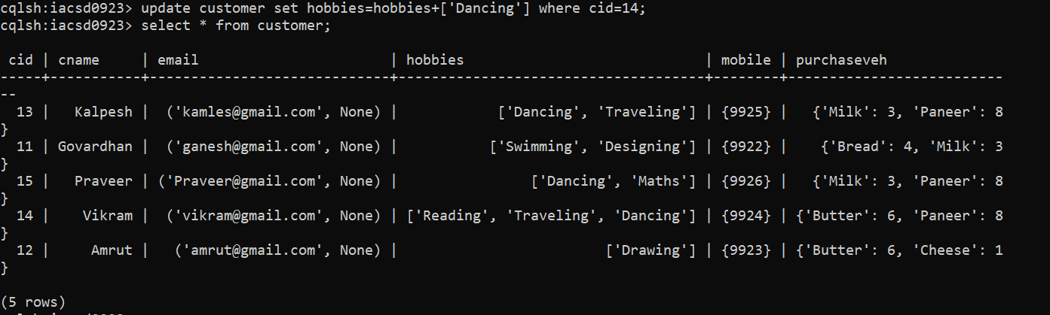

**9.change the quantity of vehicle activa from customer id 15**

cqlsh:iacsd0923> select * from customer;

cid | cname | email | hobbies | mobile | purchaseveh

-----+-----------+-----------------------------+-------------------------------------+--------+---------------------------------------

13 | Kalpesh | ('kamles@gmail.com', None) | ['Dancing', 'Traveling'] | {9925} | {'Milk': 3, 'Paneer': 8}

11 | Govardhan | ('ganesh@gmail.com', None) | ['Swimming', 'Designing'] | {9922} | {'Bread': 4, 'Milk': 3}

15 | Praveer | ('Praveer@gmail.com', None) | ['Dancing', 'Maths'] | {9926} | {'Activa': 1, 'Milk': 3, 'Paneer': 8}

14 | Vikram | ('vikram@gmail.com', None) | ['Reading', 'Traveling', 'Dancing'] | {9924} | {'Butter': 6, 'Paneer': 8}

12 | Amrut | ('amrut@gmail.com', None) | ['Drawing'] | {9923} | {'Butter': 6, 'Cheese': 1}

(5 rows)

cqlsh:iacsd0923> update customer set purchaseveh=purchaseveh+{'Activa':10} where cid=15;

cqlsh:iacsd0923> select * from customer;

cid | cname | email | hobbies | mobile | purchaseveh

-----+-----------+-----------------------------+-------------------------------------+--------+----------------------------------------

13 | Kalpesh | ('kamles@gmail.com', None) | ['Dancing', 'Traveling'] | {9925} | {'Milk': 3, 'Paneer': 8}

11 | Govardhan | ('ganesh@gmail.com', None) | ['Swimming', 'Designing'] | {9922} | {'Bread': 4, 'Milk': 3}

15 | Praveer | ('Praveer@gmail.com', None) | ['Dancing', 'Maths'] | {9926} | {'Activa': 10, 'Milk': 3, 'Paneer': 8}

14 | Vikram | ('vikram@gmail.com', None) | ['Reading', 'Traveling', 'Dancing'] | {9924} | {'Butter': 6, 'Paneer': 8}

12 | Amrut | ('amrut@gmail.com', None) | ['Drawing'] | {9923} | {'Butter': 6, 'Cheese': 1}

(5 rows)

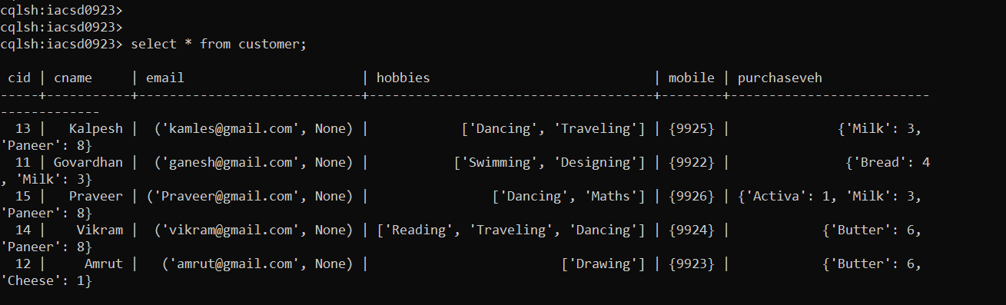

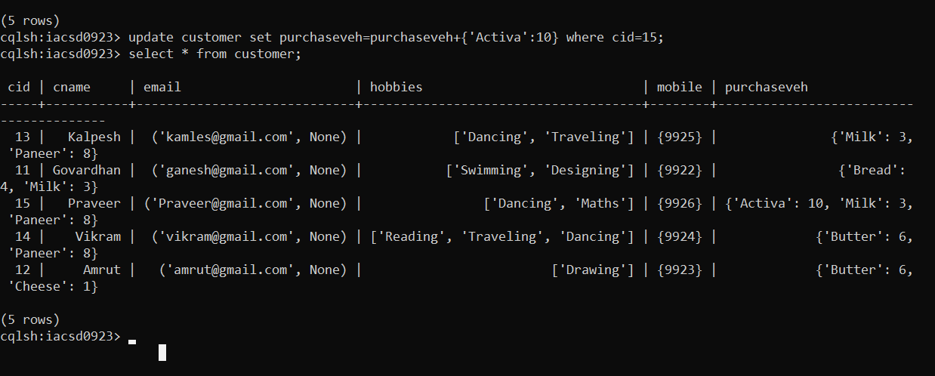

**Q2 Create a batch to**

**add 2 records in customer table,**

**delete record for customer 13 and**

**delete only email from customer 11 and**

**update emails for customer 12**

cqlsh:iacsd0923> begin batch

... insert into customer (

... cid,cname, email, hobbies, mobile, purchaseveh)

... values(

... 16,'Prajwal',('prajwal@gmail.com'),['Cycling', 'Singing'],

... {9927},{'Pulsar':1,'Jawa':2});

... insert into customer (

... cid,cname, email, hobbies, mobile, purchaseveh)

... values(

... 17,'Guddu',('guddu@gmail.com'),['Horse Riding', 'Chess'],

... {9928},{'Pulsar':3,'Jawa':1});

... delete from customer where cid=13;

... delete email from customer where cid=11;

... update customer set email=('amru@gmail.com','amu@gmail.com') where cid=12;

... apply batch;

cqlsh:iacsd0923> select * from customer;

cid | cname | email | hobbies | mobile | purchaseveh

-----+-----------+-------------------------------------+-------------------------------------+--------+----------------------------------------

16 | Prajwal | ('prajwal@gmail.com', None) | ['Cycling', 'Singing'] | {9927} | {'Jawa': 2, 'Pulsar': 1}

11 | Govardhan | null | ['Swimming', 'Designing'] | {9922} | {'Bread': 4, 'Milk': 3}

15 | Praveer | ('Praveer@gmail.com', None) | ['Dancing', 'Maths'] | {9926} | {'Activa': 10, 'Milk': 3, 'Paneer': 8}

14 | Vikram | ('vikram@gmail.com', None) | ['Reading', 'Traveling', 'Dancing'] | {9924} | {'Butter': 6, 'Paneer': 8}

17 | Guddu | ('guddu@gmail.com', None) | ['Horse Riding', 'Chess'] | {9928} | {'Jawa': 1, 'Pulsar': 3}

12 | Amrut | ('amru@gmail.com', 'amu@gmail.com') | ['Drawing'] | {9923} | {'Butter': 6, 'Cheese': 1}

(6 rows)

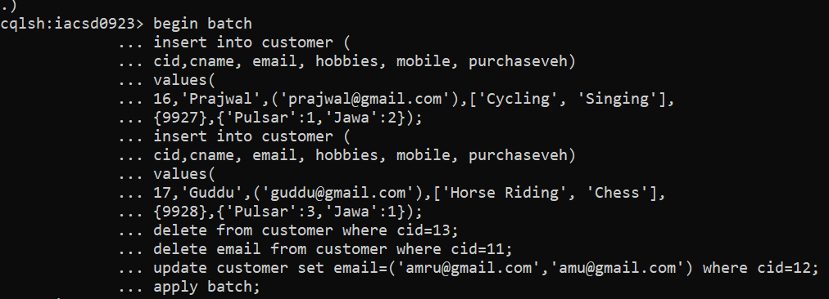

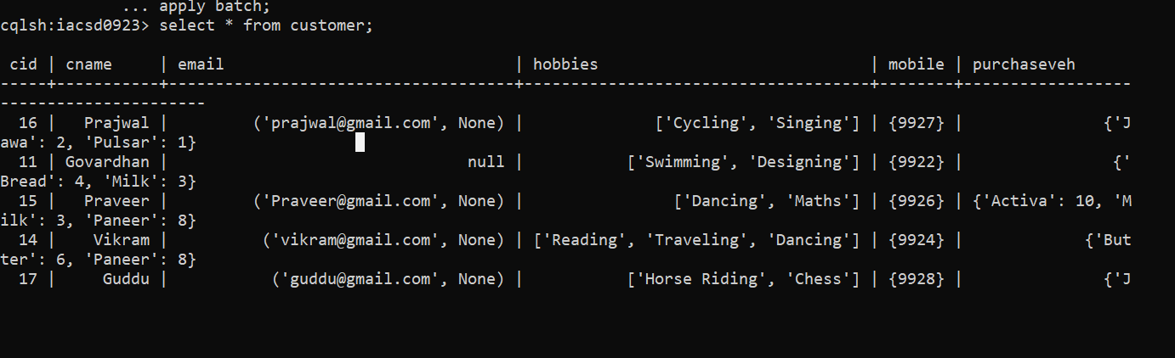

**Q3. create type department to store deptno, dname**

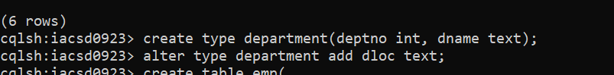

**a. change the type department to add dloc in it.**

**create table emp to store**

**eid, ename, sal, projects List<text>, dept department**

**add 5 records in the table**

cqlsh:iacsd0923> insert into emp ( eid, dept, ename, projects, sal) values (1,{deptno:1, dname:'CLERK', dloc:'Pune'}, 'Noddy', ['App', 'Web'], '30,000');

cqlsh:iacsd0923> select * from emp;

eid | dept | ename | projects | sal

-----+-------------------------------------------+-------+----------------+--------

1 | {deptno: 1, dname: 'CLERK', dloc: 'Pune'} | Noddy | ['App', 'Web'] | 30,000

(1 rows)

cqlsh:iacsd0923> insert into emp ( eid, dept, ename, projects, sal) values (2,{deptno:2, dname:'DEVELOPER', dloc:'Pune'}, 'Moody', ['App'], '35,000');

cqlsh:iacsd0923> insert into emp ( eid, dept, ename, projects, sal) values (3,{deptno:3, dname:'ADMIN', dloc:'Pune'}, 'Cody', ['Backend'], '25,000');

cqlsh:iacsd0923> insert into emp ( eid, dept, ename, projects, sal) values (4,{deptno:2, dname:'DEVELOPER', dloc:'Pune'}, 'Rhody', ['Web'], '30,000');

cqlsh:iacsd0923> insert into emp ( eid, dept, ename, projects, sal) values (5,{deptno:2, dname:'MANAGER', dloc:'Mumbai'}, 'Tony', ['App'], '35,000');

cqlsh:iacsd0923> select * from emp;

eid | dept | ename | projects | sal

-----+-----------------------------------------------+-------+----------------+--------

5 | {deptno: 2, dname: 'MANAGER', dloc: 'Mumbai'} | Tony | ['App'] | 35,000

1 | {deptno: 1, dname: 'CLERK', dloc: 'Pune'} | Noddy | ['App', 'Web'] | 30,000

2 | {deptno: 2, dname: 'DEVELOPER', dloc: 'Pune'} | Moody | ['App'] | 35,000

4 | {deptno: 2, dname: 'DEVELOPER', dloc: 'Pune'} | Rhody | ['Web'] | 30,000

3 | {deptno: 3, dname: 'ADMIN', dloc: 'Pune'} | Cody | ['Backend'] | 25,000

(5 rows)

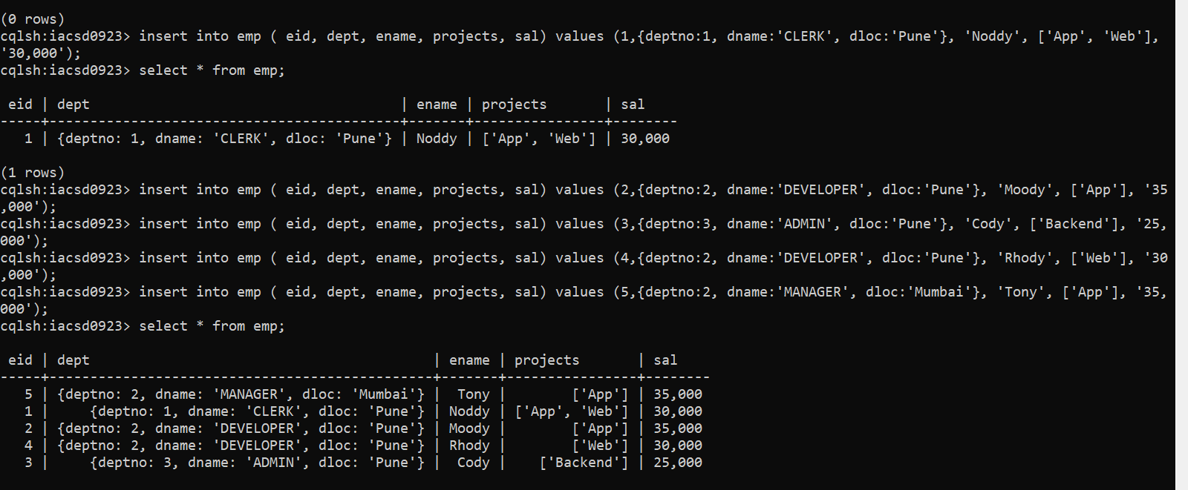

**b. create index on ename column**

cqlsh:iacsd0923> create index idxname on emp(ename);

cqlsh:iacsd0923> select * from emp;

eid | dept | ename | projects | sal

-----+-----------------------------------------------+-------+----------------+--------

5 | {deptno: 2, dname: 'MANAGER', dloc: 'Mumbai'} | Tony | ['App'] | 35,000

1 | {deptno: 1, dname: 'CLERK', dloc: 'Pune'} | Noddy | ['App', 'Web'] | 30,000

2 | {deptno: 2, dname: 'DEVELOPER', dloc: 'Pune'} | Moody | ['App'] | 35,000

4 | {deptno: 2, dname: 'DEVELOPER', dloc: 'Pune'} | Rhody | ['Web'] | 30,000

3 | {deptno: 3, dname: 'ADMIN', dloc: 'Pune'} | Cody | ['Backend'] | 25,000

(5 rows)

